

[**Geographical Information Systems**](https://dit-bb.blackboard.com/webapps/blackboard/execute/launcher?type=Course&id=_3119_1&url=)

Assignment 3

Happy Valley Ski Area

DT228

BSc in Computer Science

**Paul Petrisor**

**C15735611**

School of Computing

Dublin Institute of Technology

05th May 2019



# Part 1

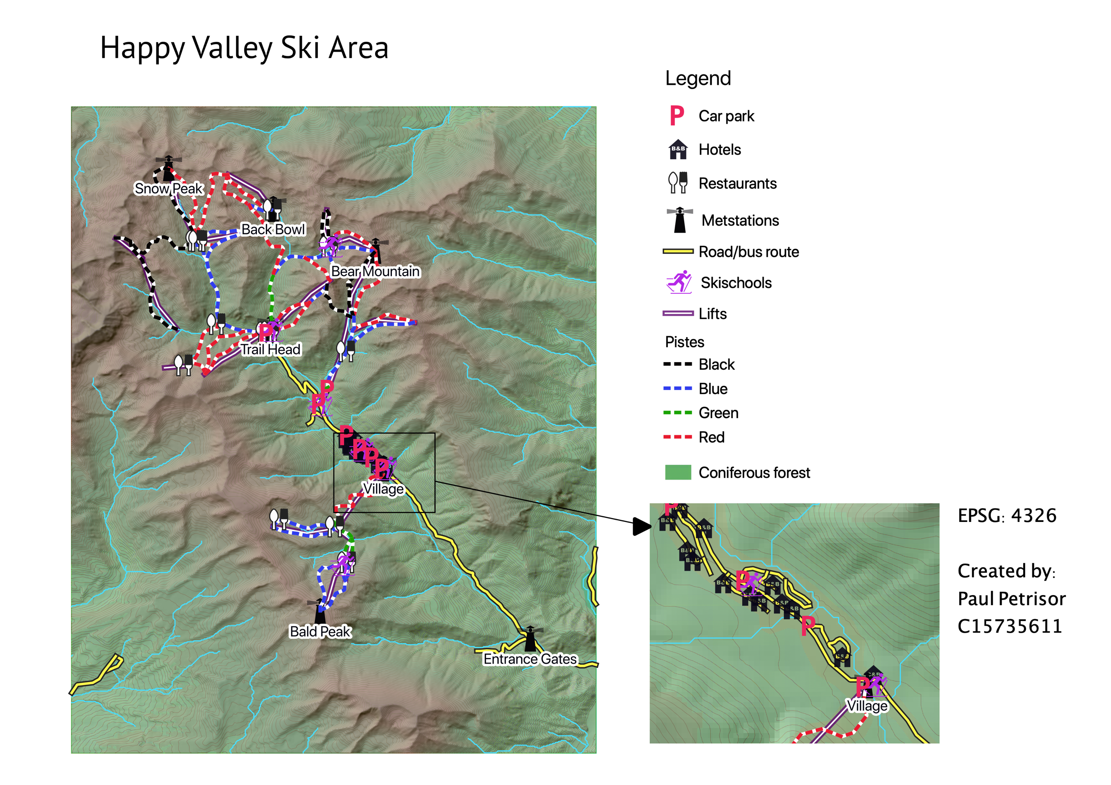

The map above outlines some of the infrastructure elements available in the Happy Valley Ski Area. The Village area has been zoomed in so that some elements ca be more visible.

The higher areas are shown in brown while the lower areas with forest and other vegetation types are displayed in green.

# Part 2

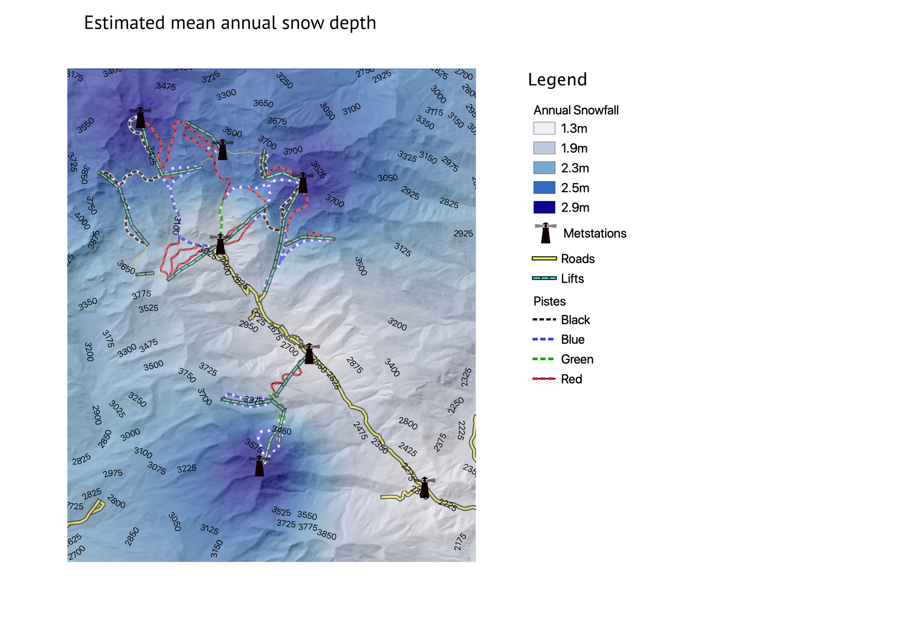

This image was create using Inverse Distance Weighting interpolation algorithm. Snowfall data has been taken from the met stations annual recorded mean values. The contour and heights have been added for a better understanding of the map. It can be observed that the minimum is recorded closed to the bottom of the valley, measuring 1.3 metres annual mean. Closer to the top of the mountains is recorded the maximum mean value of 2.9 metres.

Other key elements of the area like metstations, roads, pistes and lifts are displayed for context.

# Part 3

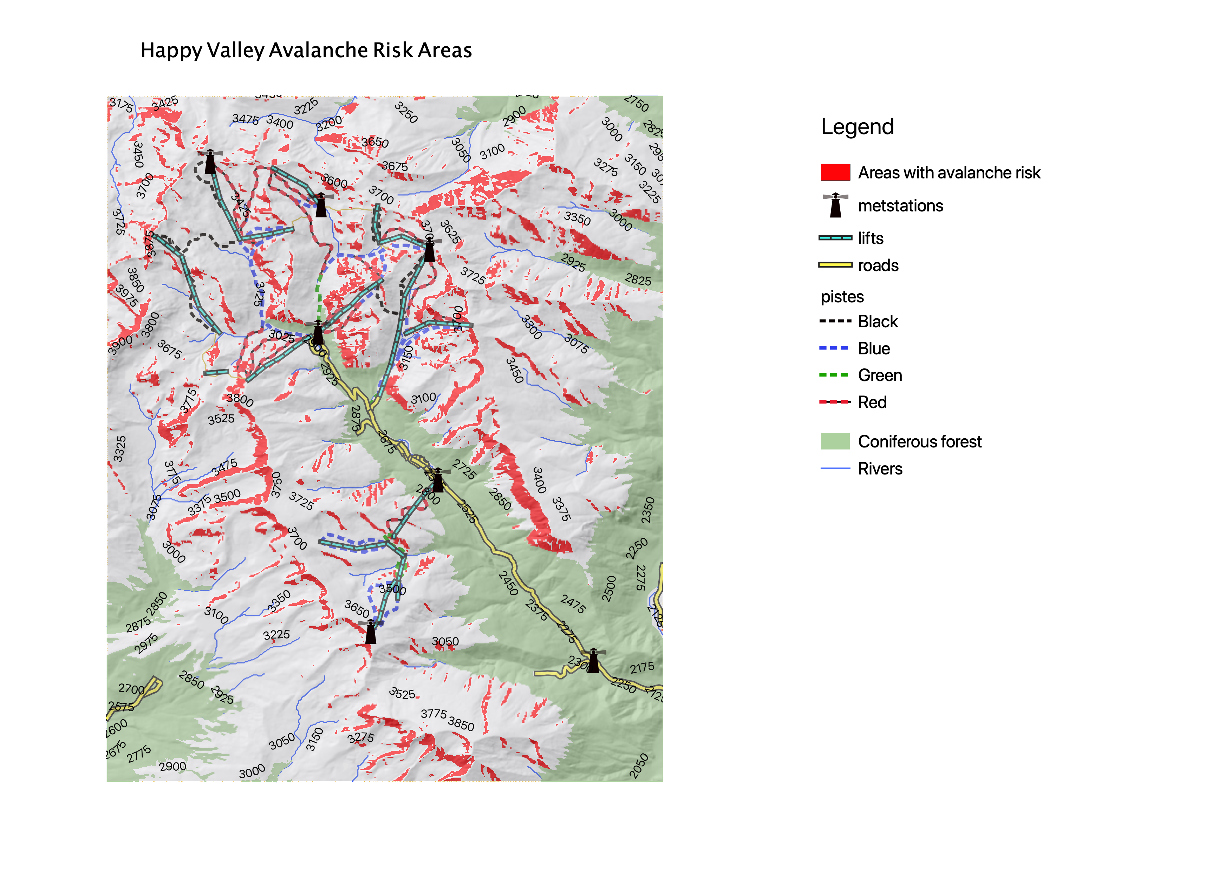

The image above displays the zones susceptible to avalanche risks.

The rules used to obtain these areas were:

* A slope between 20 and 45 degrees has been calculated.
* The areas facing west, between 180 and 360 degrees have been included for this exercise.
* Forested areas have been excluded as they don’t represent a high risk.

Some element of infrastructure available have been displayed for the attention of management and users.

# Part 4

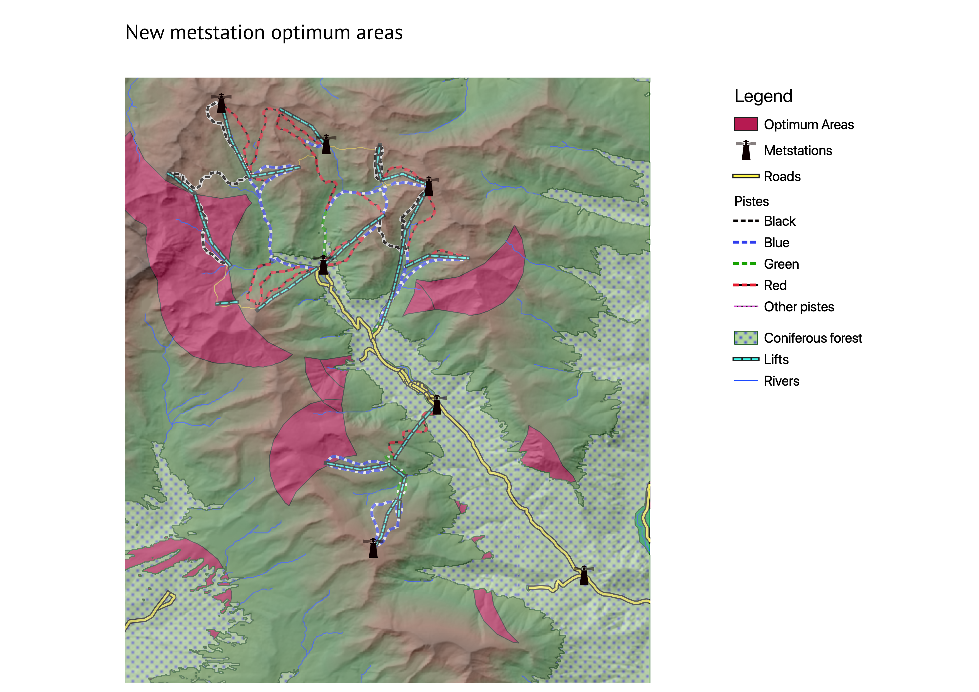

The pink/red buffers are indicating the proposed locations for the new met station.

The rules used to determine these areas were:

* The area must be at least 5km away from any existing met station.
* The area must be within 3km from any road OR pistes
* Any selected area must not be a forest area.

The QGIS geoprocessing tool have been used to determine the optimum zones. First the zones representing roads, pistes and metstations have been created. Then the union of roads and pistes buffers was created, from which the metstation 5km buffers have been extracted to give as output the optimum zones for a new metstation.

Some key elements of the area as well as the forest areas have been also displayed.